Rockland GI & Liver Disease Practice Group

**William S. Silver, MD**

DATE:

TIME:

**Eric L. Tatar, MD**

**Svetlana Korenfeld, MD**

2 Medical Park Drive West Nyack, NY 10994

845-362-3300

***PURCHASE over the counter- MIRALAX 8.3oz bottle, 4 Dulcolax laxative tablets, & 96oz of Gatorade or clear liquids***

**DAY BEFORE THE EXAM:**

**1.** Eat a light breakfast before 8am (eggs, cereal, toast, bagel, juice, coffee or tea), after breakfast maintain a clear liquid diet.

**2.** Sometime after 4pm take 4 Dulcolax tablets, which can be found over the counter at any pharmacy. 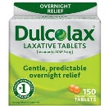

**3.** At 4:00 p.m. mix the Miralax powder with 96 oz. of Gatorade, Powerade, Crystal Lite, applejuice or any other clear beverage (NO red or blue). Drink entire mixture within 3 to 4 hours. If cramping or bloating occurs you may use Mylicon, Gas-X, or Mylanta.

[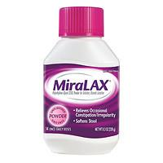](javascript:popUp('/popups/largerphoto/default.asp?pid=163280&catid=172&size=300&trx=29888&trxp1=163280&trxp2=1','popup',550,380))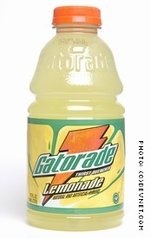

+

**8.3 oz bottle of Miralax powder 96oz. of Gatorade or clear liquid**

**4.** You can have clear liquids up until midnight, **AFTER MIDNIGHT NOTHING TO DRINK**.

**CLEAR LIQUIDS ALLOWED THE DAY BEFORE THE PROCEDURE**

WATER, CLEAR FRUIT JUICE, (APPLE, GRAPE, CRANBERRY) BOUILLON, COFFEE, TEA, GRAPEFRUIT JUICE, (NO PULP) SODA, ICED TEA, PLAIN JELLO.

**\*\*\*NO SOLID FOODS, MILK, DAIRY PRODUCTS, and NO RED or BLUE JELLO OR ALCOHOLIC BEVERAGES\*\*\***

**DAY OF THE EXAM:**

1. Nothing to eat or drink until AFTER the procedure.

2**. YOU MUST BE ACCOMPANIED BY A DRIVER IN ORDER TO HAVE YOUR PROCEDURE , NO CAR SERVICE ALLOWED unless accompanied by responsible adult ***IF YOU DO NOT HAVE A DRIVER PLEASE CALL TO RESCHEDULE – NO DRIVING FOR 24 HOURS AFTER PROCEDURE*** If Driver doesn’t come up with you a staff member will walk you to your car.**

**STOP ONE WEEK PRIOR TO PROCEDURE**

*ASPIRIN, NAPROSYN, CELEBREX, MOBIC , MULTIVITAMINS WITH IRON, VITAMIN E. , PLAVIX, COUMADIN*

*If you take ozempic, Wegovy, Rybelsus, Trulicity, mounjaro, saxenda, or victoza-*

*please stop 7 days prior to procedure.*

*XARELTO, ELIQUIS stop 48 hours prior to procedure*

*Please NOTE: Patients with Heart Disease or stroke may continue to take ASPIRIN*

**\*DO NOT TAKE DIABETIC MEDICATION MORNING OF TEST\***

***\*TAKE BLOOD PRESSURE MEDICATION MORNING OF TEST\****

*IF YOU HAVE ANY PAIN THE WEEK PRIOR USE ONLY* ***TYLENOL*.**

*PLEASE NOTIFY OUR OFFICE IF YOU HAVE HAD VALVULAR HEART REPLACEMENT*